**Query Optimization**

**Problem statement :** optimize Query in question no2 to finddonation amount, ads spending, total donation, pageview, conversion rate percentage (no of donation/pageview), % spending per donation amount per campaign each day on postgres SQL.

Query

SELECT created_dt,campaign_id,title,URL,donation_amount,total_donation,

ads_spending,total_pageview,(total_donation/total_pageview::FLOAT)*100 AS convertion_rate,(ads_spending/donation_amount::FLOAT)* 100 AS spending_per_donation_rate

FROM (SELECT don.created_dt,campaign_id,title,don.URL,donation_amount,total_donation,

SUM(spend) OVER(PARTITION BY don.created_dt,campaign_id) AS ads_spending,

SUM(V.pageview) OVER(PARTITION BY don.created_dt,campaign_id) AS total_pageview

FROM (SELECT date_trunc('day', D.created) AS created_dt,D.campaign_id,C.title,C.URL,

SUM(D.amount) OVER (PARTITION BY date_trunc('day', D.created),campaign_id) AS donation_amount,

COUNT(D.user_id) OVER (PARTITION BY date_trunc('day', D.created),campaign_id) AS total_donation

FROM donations D

INNER JOIN campaign C ON D.campaign_id = C.ID) don

LEFT JOIN ads_spent ads ON don.created_dt = ads.date_id AND don.URL = ads.short_url

LEFT JOIN visit V ON don.created_dt = V.date_id AND don.URL = V.campaign_url

ORDER BY 1,2) FINAL

GROUP BY 1,2,3,4,5,6,7,8 ORDER BY 9;

1. Create Index

With creating index prove can speeds up the data retrieval, there several index that we can implemented to optimize the query cost as below :

|  |  |  |
| --- | --- | --- |
| Table Name | Index Name | Index Definition |
| ads_spent | idx_ads_url | CREATE INDEX idx_ads_url ON ads_spent USING btree **(short_url)** |
| campaign | idx_campaign_url | CREATE INDEX idx_campaign_url ON campaign USING btree (**url**) |
| visit | idx_visit_url | CREATE INDEX idx_visit_url ON visit USING btree (**campaign**_**url**) |

Please find below query explain plan before and after we implement index.

**Before :**

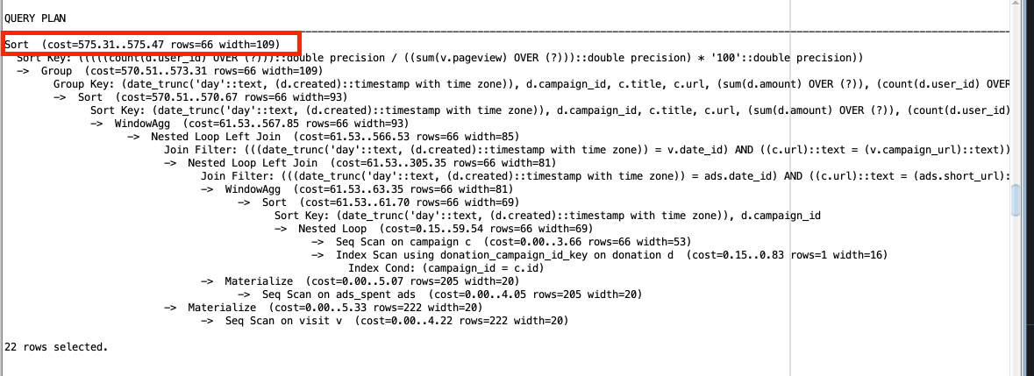

**After**

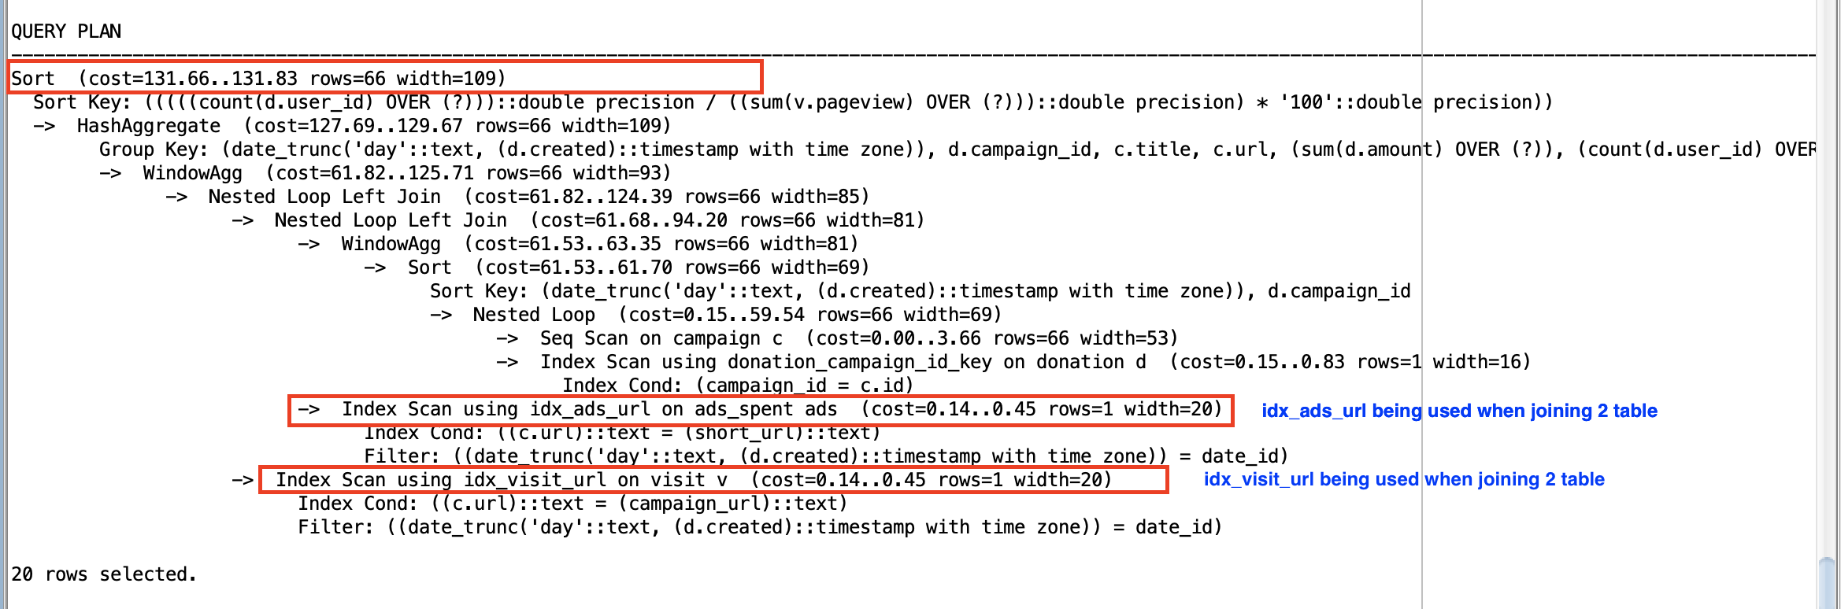

As seen on the image obove that the query cost improve by 77% after index being implemented.